1. Complete the table to summarise the breadboard components. On page 7 there is a blank table to fill in any other components, problems and solutions you come across.

Component Name | Diagram | How it works | If my circuit isn’t working what could have gone wrong | What could I do to fix it
_______________  _______________ | 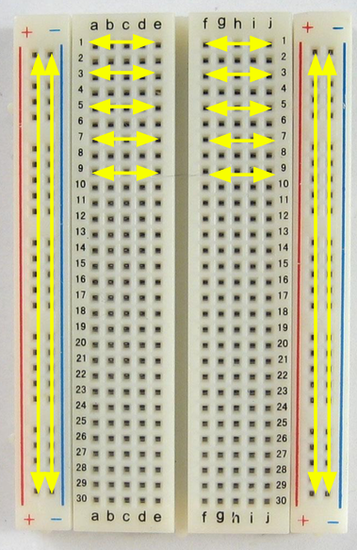 | - Inside the board are many  strips of _______ that connect the  rows and columns together. Rows are linked together but not across the divider. | - - Little metal clips on the inside aren’t working well  - - Components were set up across the divider  - Components not set up horizontally in rows or vertically in columns | - - Try poking them with your finger or ________ it to a different section  - - Make sure your components are linked to form a circuit. Pretend you are an electron and follow the path you would take
Hook up wire | 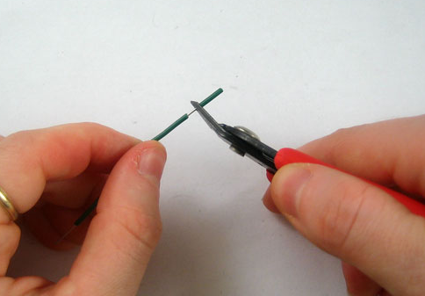 | - Insulated wire that is cut down and has the insulation pulled off  - Use a ________________________ to pull the plastic end off the wire (it takes a few tries but then its really easy
________________ | 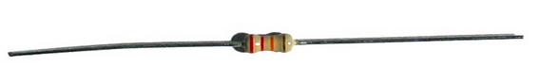 | - Resists the flow of _________________________  - Can be placed in ____ direction  - Use the resistor calculator on moodle to calculate the value of a resistor
Light emitting diode (LED) | 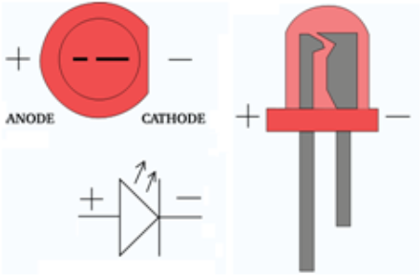 | - Turns current into light  - Can only go in ______ direction (positive to negative)  - The positive leg is longer  - Always use a _______________ | - LED will not work if it is placed _____________  - LED will _______ if not placed with a resistor (at least 1.0K ohm) | - Try flipping the LED around  - Always place LED with a resistor
Diode | 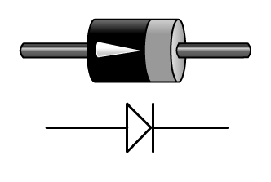 | - only allow current to pass through them in _____ direction.  - The arrowhead on the symbol shows the _____________ of current flow. | - Will not allow to current to pass if it is placed backwards | - Try flipping the diode around
Capacitor | 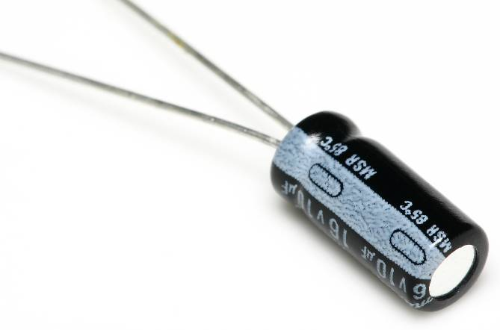 | - Stores charge  - Maintain current for a short time  - Can only be placed in _________ direction | - Will not allow to current to pass if it is placed backwards | - _______________  _______________  _______________
Push button | 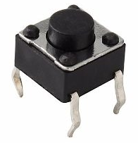 | - Connects two points in a circuit when you press it | - The pushbutton is square, and because of this it is  easy to put it in the wrong way | - Try giving it a 90 degree twist and see if it starts working.
Transistor | 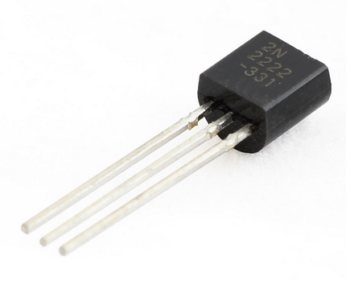 | - used to amplify or switch _____________________ signals and power
Power supply | 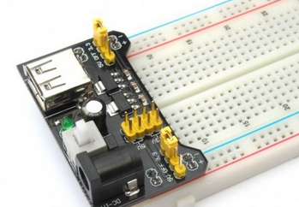 | - Regulates voltage supplied to breadboard – either 5V or  3.3V to power _______________ rails | - Switch not on  - Voltage not being supplied  - Input voltage not correct | - Switch on  - Voltage set at 3V or 5V  - Input voltage between 6.5-12V  - Firmly pressed into power rails
Arduino Board | 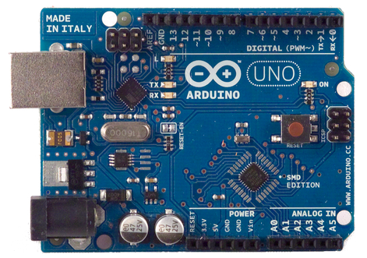 | - Upload instructions (_________) to the board using the USB cable  - The arduino board will perform the  instruction you uploaded | - Components and wires not connected correctly | - Look closely at your diagram instructions and make sure everything is connected just as it is in the picture

Project one – Goal: Get the light to turn on when you press the switch
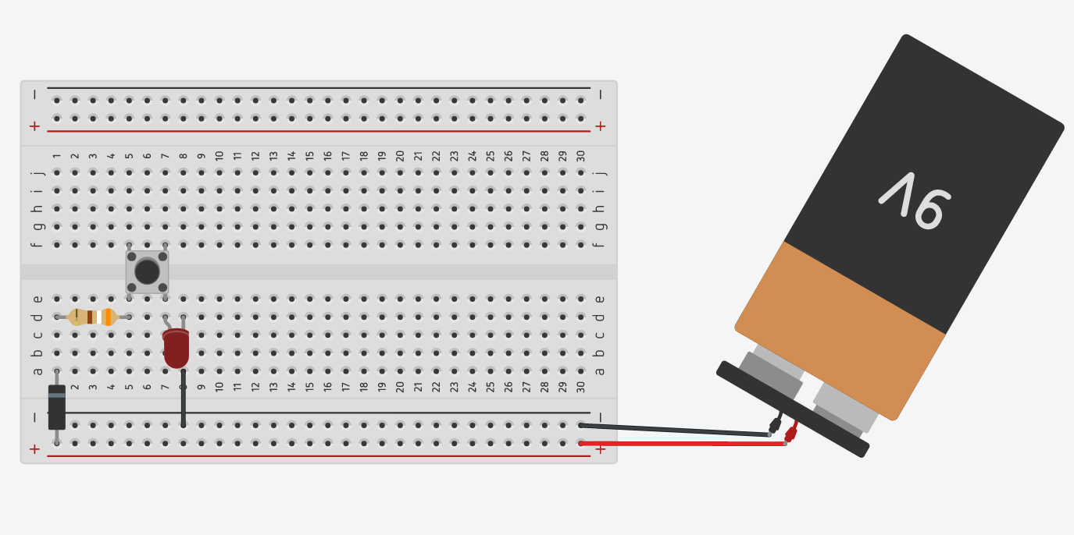
If it’s not working:

- Be patient
- Go through your troubleshooting steps
- See 3 before me
- Write your name on the whiteboard

Remember:

- You will get a learning merit if you complete a project
- You will get a NFOA merit for helping another student complete a project

Bonus activity: What happens if you connect the diode the other way around? Now try the resistor and LED.

Project 2 – Goal: Use the wires to touch something that conducts electricity. The LED should light up if what you are testing is a conductor

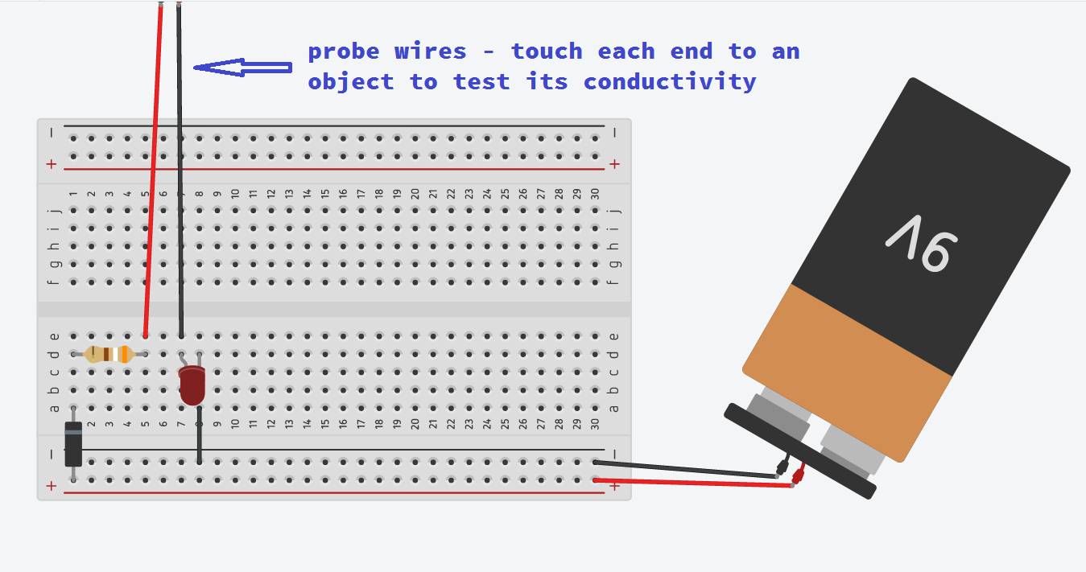
If it’s not working:

- Be patient
- Go through your troubleshooting steps
- See 3 before me
- Write your name on the whiteboard
Remember:
- You will get a learning merit if you complete a project
- You will get a NFOA merit for helping another student complete a project

Project 3 – Goal: Get the lights to alternate switching on and off

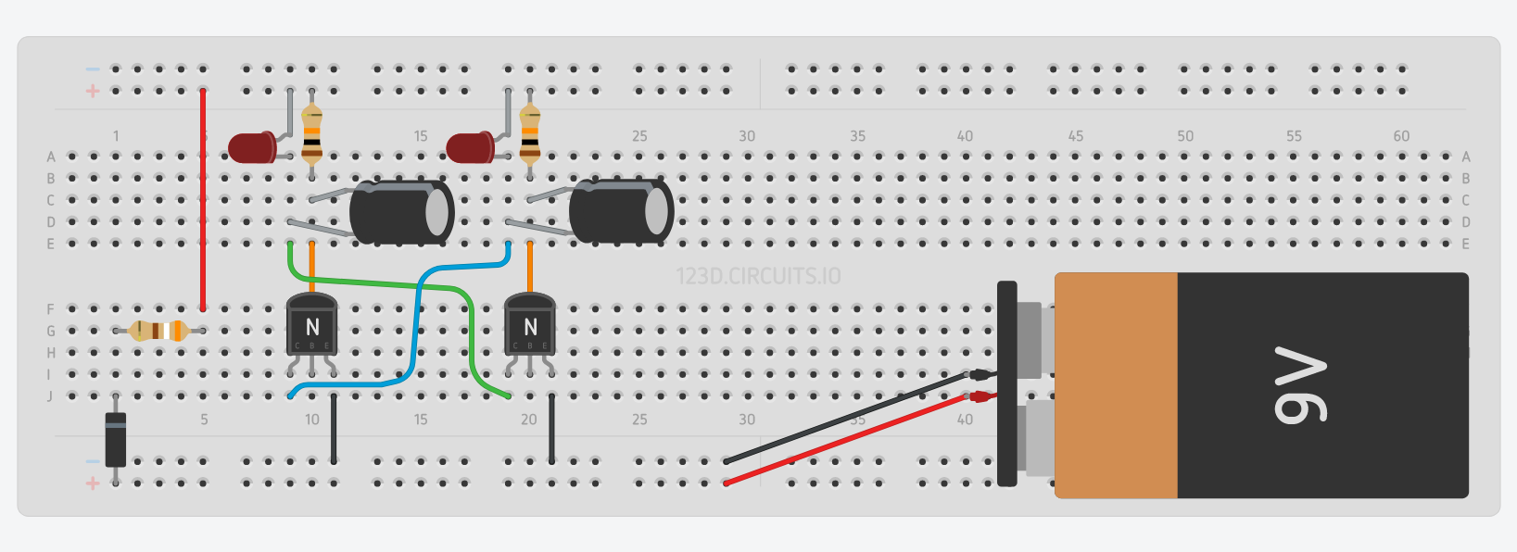
If it’s not working:

- Be patient
- Go through your troubleshooting steps
- See 3 before me
- Write your name on the whiteboard
Remember:
- You will get a learning merit if you complete a project
- You will get a NFOA merit for helping another student complete a project

Bonus activity: Can you control the LEDs by putting a switch in the circuit? What happens if you swap 100uF with 10uF capacitors?

Component | Problem | Solution | Extra Notes

